The Logger I have created is designed to be using by creating an instance of the logger class then simply calling the logging methods to log the data. There are a few options that the user can use to create the logger. One option is to use a string and pass that into the constructor with what the logging level will be. Another option is define the level via command line arguments. The logging level defines what types of messages are logged. For example if the user sets the level as WARN then the logger will capture any messages that have a level that is a “WARN” or greater such as an “ERR” message. The Level can be changed at runtime by calling a method from the logger class so the user can exclude warning or info messages whenever they want. The logger class also contains options to see what they have logged so far and also get a dynamic array from the logger class that contains all the messages that have been passed to the logger in the current build. The user can also pass in a time format with the log message so that they can format how the logger displays the timestamp for each message. This is optional because the timestamp format has a default time.

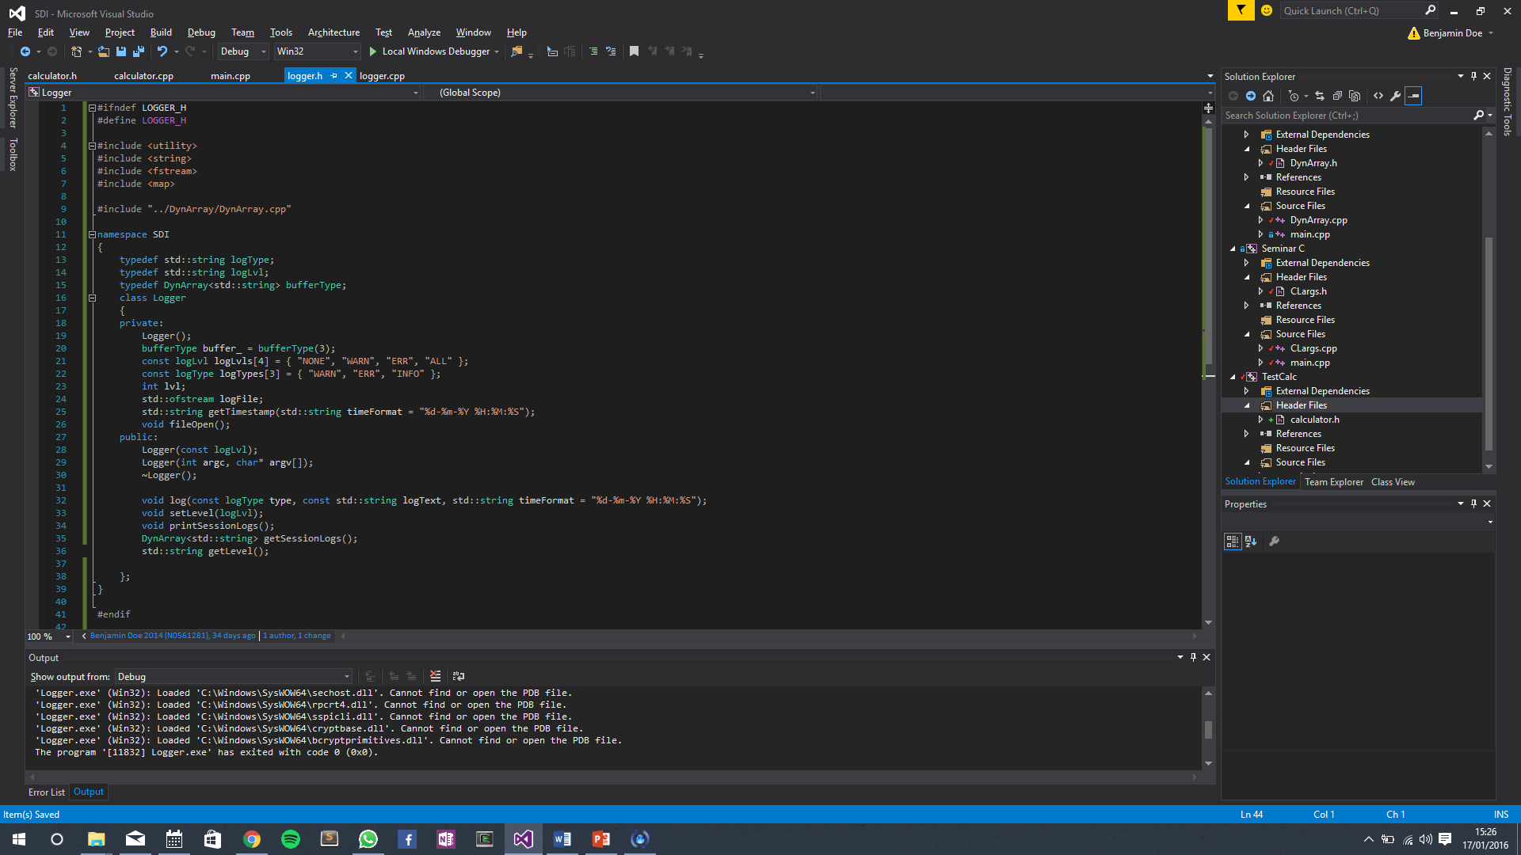 *Logger.h*

The test program I have created is a simple calculator class. It logs an INFO message whenever the calculation is successful. It also logs a warning if the result is a decimal or a negative number.